Assignment No -: 06

Que -: write two different queries that would produce all orders taken on October 3rd or 4th 1990.

1] kd2_83598>select *from orders
-> where odate in('1990-10-03','1990-10-04');
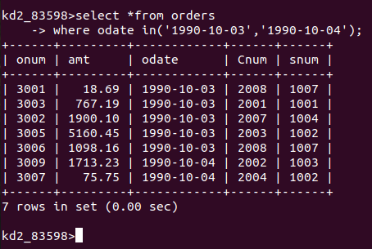

2] kd2_83598>select *from orders
-> where odate not in('1990-10-05','1990-10-06');
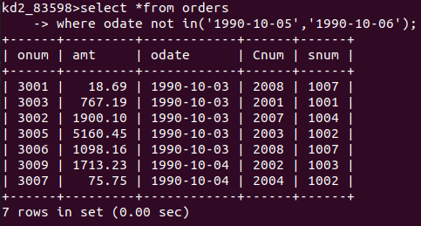

Que 2-: Write a query that selects all of the Customers serviced by peel or motika

kd2_83598>select salespeople.Snum,salespeople.Sname,Customers.Cname from Customers,salespeople
-> where salespeople.Snum=Customers.Snum and Sname in('peel','Motika');

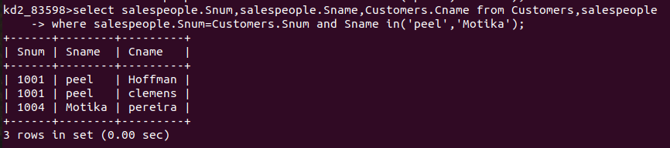
Que 3 -: Write a Query That will produce all the customers whose names begin with a letter from ‘A’ to ‘G’.

kd2_83598>select *from Customers
-> where Cname between 'A' and 'H';

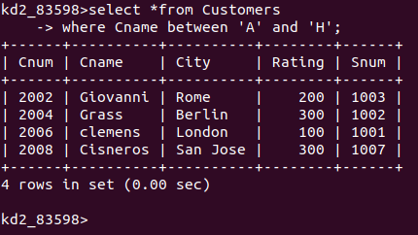

Que 4-: Write A Query that Selects all customers whose names begin with letter ‘C’.

kd2_83598>select *from Customers
-> where Cname like 'C%';

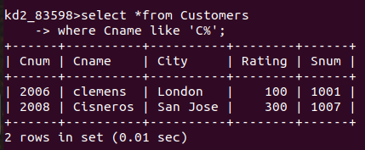

Que 5 -: Write A query that selects all orders except those with zeroes or nulls in the Amount field .

kd2_83598>select *from orders
-> where amt is not null and amt!=0;

